|  |  |  |  |
| --- | --- | --- | --- |
| **Use-Case Name:** | **Project system** | | **Use Case Type**  **Business Requirements:**  **Create project proposal** |
| **Use Case ID:** | **PS-001** | |
| **Priority:** | **High** | |
| **Source:** |  | |
| **Primary Business Actor:** | **Stakeholder** | | |
| **Other Participating Actor:** | **Stakeholder** | | |
| **Other Interested Stakeholders:** | **Team** | | |
| **Description:** | **This use case describes that the page of create proposal would occur in which stakeholder has to make a tender and then send it to govt/pvt sector giving 10% of the payment to the member.** | | |
| **Precondition:** | **The project must be given in the newspaper so that it’s proposal can be made.** | | |
| **Trigger:** | **The user has to click on the ‘create project proposal’ button to proceed.** | | |
| **Typical Course of Events:** | **Actor Action** | **System Response** | |
| **STEP NO.1: the member request the option to create new project proposal.**  **STEP NO.3: the member enters complete information.**  **STEP NO.5: if no change is needed, the member clicks on the continue (button).** | **STEP NO.2: the system responds by displaying a page asks project kind, stakeholder name, newspaper name, duration to complete that project, total cost of project, organization name(each information is compulsory).**  **STEP NO.4: once the entire information is entered, then system sent it back to the member to verify it.**  **STEP NO.6: the system after verification shows up the project proposal along with all that information.** | |

**DESGIN USED CASED**

|  |  |
| --- | --- |
| **Alternate Course:** | **STEP NO.3: if complete information is not obligatory, then just provide the organization name and total cost needed for the project.**  **STEP NO.5: if change is needed, then click on the button to update the information.** |
| **Conclusion:** | **If complete information is provided to the system , then proposal would be made.** |
| **Post condition:** | **The information given by the member has been recorded by the system , then after verification, the system will generate the project proposal.** |
| **Business Rules:** | 1. **Stakeholder must enter the valid information asked by the system.** |
| **Implementation Constraints and Specification:** |  |
| **Assumption:** | **Maybe complete information is not given by the stakeholder.** |
| **Open Issues:** | **Maybe govt/pvt sector would not accept the project proposal.** |

# DESGIN USED CASED

|  |  |  |  |
| --- | --- | --- | --- |
| **Use-Case Name:** | **Project system** | | **Use Case Type**  **Business Requirements:**  **Create project proposal** |
| **Use Case ID:** | **PS-001** | |
| **Priority:** | **High** | |
| **Source:** |  | |
| **Primary Business Actor:** | **Stakeholder** | | |
| **Other Participating Actor:** | **Stakeholder** | | |
| **Other Interested Stakeholders:** | **Team** | | |
| **Description:** | **This use case describes that the page of create proposal would occur in which stakeholder has to make a tender and then send it to govt/pvt sector giving 10% of the payment to the member.** | | |
| **Precondition:** | **The project must be given in the newspaper so that it’s proposal can be made.** | | |
| **Trigger:** | **The user has to click on the ‘create project proposal’ button to proceed.** | | |
| **Typical Course of Events:** | **Actor Action** | **System Response** | |
| **STEP NO.1: the member request the option to create new project proposal.**  **STEP NO.3:**  **STEP NO.5: if no change is needed, the member clicks on the continue (button).** | **STEP NO.2: the system responds by displaying a page asks project kind, stakeholder name, newspaper name, duration to complete that project, total cost of project, organization name(each information is compulsory).**  **Step 3 : Member send the tender to government .**  **STEP NO.4: once the entire information is entered, then system sent it back to the member to verify it.**  **STEP NO.6: the system after verification shows up the project proposal along with all that information.** | |

|  |  |
| --- | --- |
| **Alternate Course:** | **STEP NO.3: if complete information is not obligatory, then just provide the organization name and total cost needed for the project.**  **STEP NO.5: if change is needed, then click on the button to update the information.**  **Step 4 if the information is not true just popped the message that information is not true** |
| **Conclusion:** | **If complete information is provided to the system , then proposal would be made.** |
| **Post condition:** | **The information given by the member has been recorded by the system , then after verification, the system will generate the project proposal.** |
| **Business Rules:** | 1. **Stakeholder must enter the valid information asked by the system.** |
| **Implementation Constraints and Specification:** |  |
| **Assumption:** | **Maybe complete information is not given by the stakeholder.** |
| **Open Issues:** | **Maybe govt/pvt sector would not accept the project proposal.** |

## PARTIAL OBJECT DIAGRAM

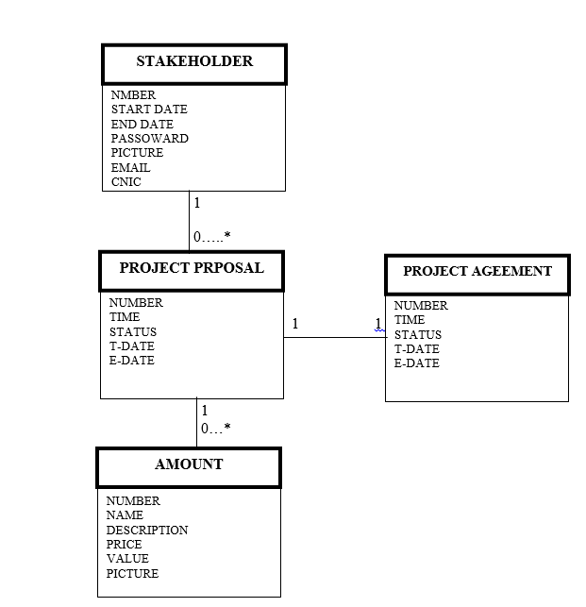

**DESIGN USE CASE DIAGRAM**

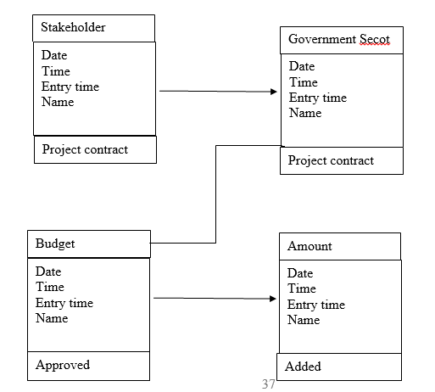

**SEQUENCE DIAGRAM:**

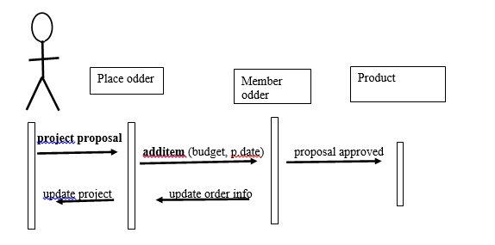

## INPUT PROTOTYPE

CMS Sequence Diagram Input Prototype:

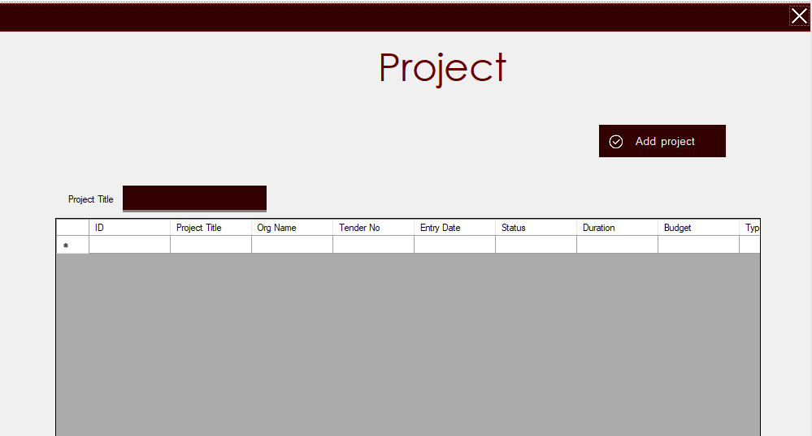

## OUTPUT PROTOTYPE

CMS Sequence Diagram Output Prototype:

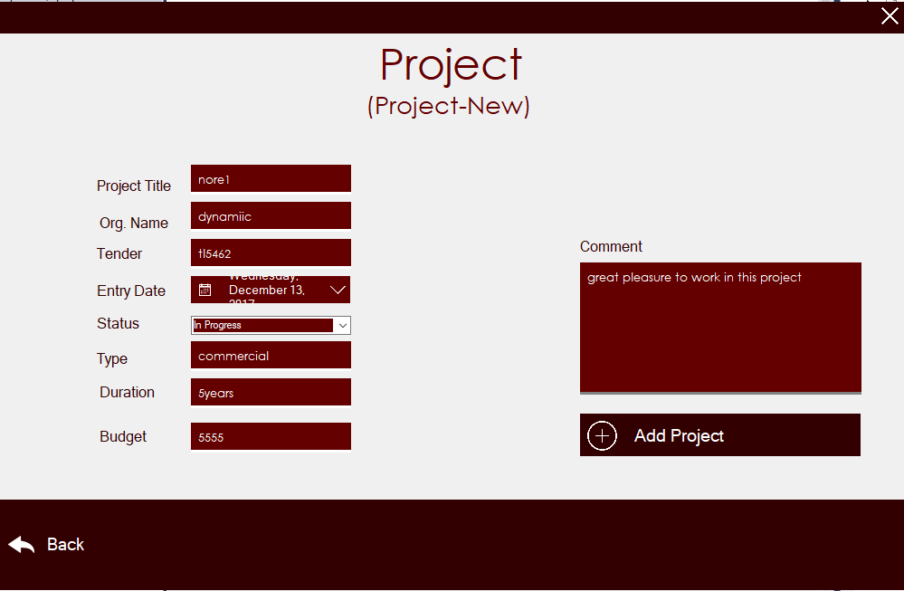

**DESGIN USED CASED**

|  |  |  |  |  |  |
| --- | --- | --- | --- | --- | --- |
| **Use-Case Name:** | | **Project system.** | | **Use Case Type**  **Business Requirements:**  **Get new project contract.** | |
| **Use Case ID:** | | **PS-002** | |
| **Priority:** | | **High** | |
| **Source:** | |  | |
| **Primary Business Actor:** | | **Stakeholder** | | | |
| **Other Participating Actor:** | | **Stakeholder** | | | |
| **Other Interested Stakeholders:** | | **Team** | | | |
| **Description:** | | **This use case describes that the member (stakeholder) gets the new project contract stated in the newspaper, then member opens an interface to create a tender which is then send it to govt/pvt sector. If they accepted the tender, member gets an email that their project has been accepted.** | | | |
| **Precondition:** | | **You need to look on the newspaper to get New Project Contract.** | | | |
| **Trigger:** | | **Click on the ‘create tender’ button to proceed.** | | | |
| **Typical Course of Events:** | | **Actor Action** | **System Response** | | |
| **STEP NO.1: the member sees the new project contract in the newspaper.**  **STEP NO.2: the member sets the budget and clicks on the button to display a page of creating tender.**  **STEP NO.4: the member then provides complete information.**  **STEP NO.6: then user clicks on the button to send that tender to the govt/pvt sector.**  **STEP NO.8: if govt/pvt sector accepts their tender, then sends mail.** | **STEP NO.3: the system displays an interface to create a tender,**  **STEP NO.5: the system then verifies the information and provides the tender.**  **STEP NO.7: the system then responds by forwarding the tender to the govt/pvt sector.**  **STEP NO.9: the system then assures the member that the project contract is accepted by showing mail to the member.** | | |
| **Alternate Course:** | | **STEP NO.1: if new projects are not given in the newspaper, then there should be a site of having new projects.**  **STEP NO.8: if the tender is not accepted by the govt/pvt sector , then look for another project contract.** | | | |
| **Conclusion:** | | **If tender is accepted by the govt/pvt sector, then member would get the new project contract.** | | | |
| **Post condition:** | | **The tender made on the system which was sent to the govt/pvt sector if it is accepted by them, member gets an email of acceptance and so the work is started.** | | | |
| **Business Rules:** | | * **Email provided to the system must be correct.** * **Every information provided to the system must be fulfilled in the required time.** | | | |
| **Implementation Constraints and Specification:** | |  | | | |
| **Assumption:** | | **Project contract is not of a type that an organization wants.** | | | |
| **Open Issues:** | | **Maybe tender provided by the member doesn’t please the govt/pvt sector.** | | | |

## PARTIAL DIAGRAM

CMS Usecase Partial Object Diagram:

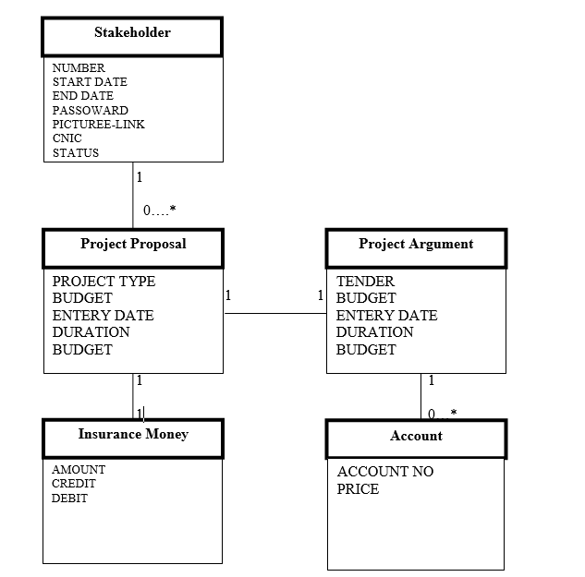

# DESIGN USED CASED DIAGRAM

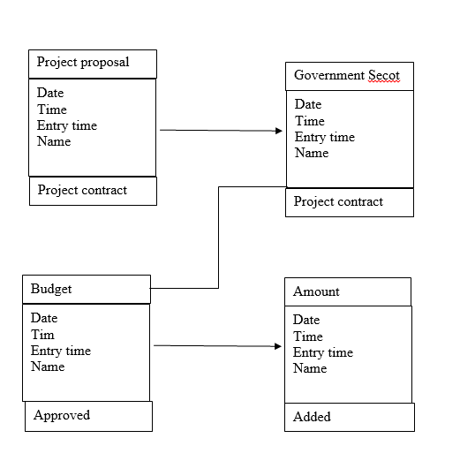

## 

## SEQUENCE DIAGRAM

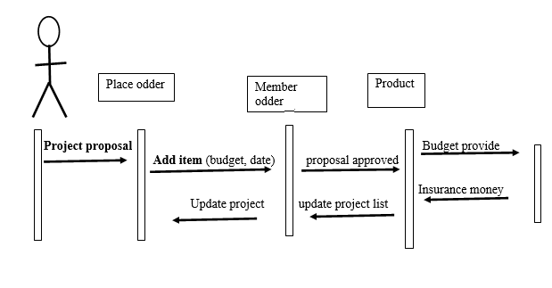

## 

## INPUT PROTOTYPE

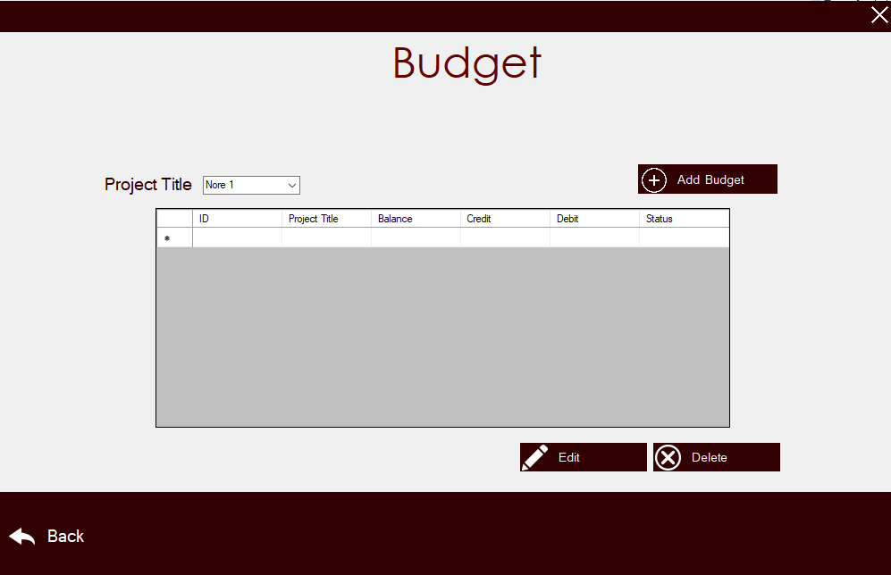

|  |  |  |  |
| --- | --- | --- | --- |
| **Use-Case Name:** | **Display stock summary** | | **Use Case Type**  **Business Requirements:**  **System analysis** |
| **Use Case ID:** | **CMS-ISUC 0002.00** | |
| **Priority:** | **High** | |
| **Source:** | **Requirement Use case-CMS.ISUC 003.00** | |
| **Primary Business Actor:** | **Suppliers** | | |
| **Other Participating Actor:** | **Supervisor** | | |
| **Other Interested Stakeholders:** | **Stakeholder: interested in availability of the product in the inventory stock in order to place order for completion of work.** | | |
| **Description:** | **This use case describes/displays the inventory list of the stock suppliers have.if the required stock is available in the inventory only the orders could be placed. Otherwise unavailability of stock will be noticed.** | | |
| **Precondition:** | **Inventory list will be checked after new order is placed.** | | |
| **Trigger:** | **This use case is initiated when new order is placed by the client.** | | |
| **Typical Course of Events:** | **Actor Action** | **System Response** | |
| **STEP NO.1: the supervisor requests to place an order.**  **STEP NO.3: the supervisor goes through the list and selects the required stock in desired quantity.**  **STEP NO.5: the supervisor reviews the order summary and confirms the order.** | **STEP NO.2: system response by displaying available inventory list.**  **STEP NO.4: system shows the selected option and generate stock summary of the selected items for order confirmation.**  **STEP NO.6: after receiving confirmation system generates a invoice billing receipt.** | |

|  |  |
| --- | --- |
| **Alternate Course:** | **STEP NO.2: if the item is not present in the inventory list, its unavailability must be displayed.**  **STEP NO.3: if the list of available stock is shown, their available quantity should also be mentioned.**  **STEP NO.5: if something got missed or something new needs to be added, desired amendments must be made before accepting Order Confirmation Summary.** |
| **Conclusion:** | **This use case concludes when the availability of the required stock is checked in inventory.** |
| **Post condition:** | **The list of the inventory is displayed. required stocks availability is checked and then availability is respond accordingly.** |
| **Business Rules:** | * **Only suppliers can view their inventory list.** * **Inventory list will be checked after new order is placed.** * **Availability of the stock will be respond accordingly.** |
| **Implementation Constraints and Specification:** | * **Use case must be only available to suppliers.** * **Use case must be updated after each and every transaction (import and export).** |
| **Assumption:** | * **List can be updated.** * **If the stock is not available, a response must be informed.** |
| **Open Issues:** | **None.** |

|  |  |  |  |
| --- | --- | --- | --- |
| **Use-Case Name:** | **Supplier order record.** | | **Use Case Type**  **Business Requirements:**  **System analysis** |
| **Use Case ID:** | **CMS-ISUC 003.00** | |
| **Priority:** | **High** | |
| **Source:** | **Requirement-CMS-MPUC 001.00** | |
| **Primary Business Actor:** | **Suppliers** | | |
| **Other Participating Actor:** | **Supervisor** | | |
| **Other Interested Stakeholders:** | * **Stakeholder: interested in order activity in order to evaluate the loss and profit.** * **Team: interested in purchase activity in order to evaluate the quality and quantity of the product.** | | |
| **Description:** | **This use case describes the event of supervisor submitting a new order for required product which is needed in inventory and is out of stock . the record is updated (budget record) after placing and receiving an order.** | | |
| **Precondition:** | **The required item must be unavailable in inventory to place a new order.** | | |
| **Trigger:** | **This use case is initiated when the stakeholder or supervisor selects the option.** | | |
| **Typical Course of Events:** | **Actor Action** | **System Response** | |
| **STEP NO.1: the supervisor requests the option to place a new order.**  **STEP NO.3: the supervisor browsers through the stock and selects the required stock in desired quantity.**  **STEP NO.4: the supervisor confirms the stock summary of the required stock.** | **STEP NO.2: the system response by displaying stock menu.**  **STEP NO.4: system stores the selections and generates a stock summary of the selected items to be confirmed.**  **STEP NO.5: once stock summary is confirmed system generates an invoice billing receipt.** | |

|  |  |
| --- | --- |
| **Alternate Course:** | **STEP NO.3: if he supervisor doesn’t find the desired stock in the list he/she can change the supplier as there are more than one supplier associated.**  **STEP NO.4: if the desired stock in out of stock system must notify the unavailability of the item.**  **STEP NO.4: if supervisor finds something enter or misses something while placing order. Order summary provides him/her with cross check and option of modification.** |
| **Conclusion:** | **This use case concludes when new order is placed.** |
| **Post condition:** | **The order has been received and if available product will be delivered or else on unavailability a bank order will be created.** |
| **Business Rules:** | * **Order is only placed when the product is unavailable in inventory.** * **If the required stock is available in inventory order will not be placed.** * **If one supplier doesn’t have the required stock other supplier will be approached, then.** * **Billing transaction will be done after product delivery.** |
| **Implementation Constraints and Specification:** | * **Use case must be available all the time.** * **Use case must not be used while in between one transaction and operation.** |
| **Assumption:** | * **Stock order confirmation will be cross check every time before placing new order.** * **The order can be canceled anytime.** |
| **Open Issues:** | **None.** |

## PARTIAL OBJECT DIAGRAM

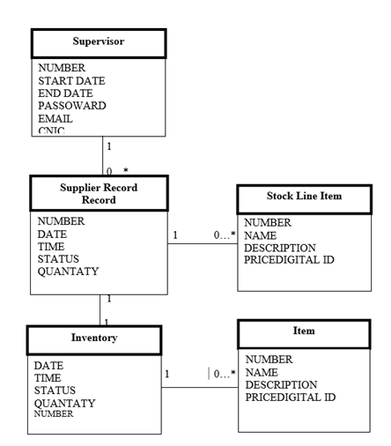

# DESIGN USED CASED

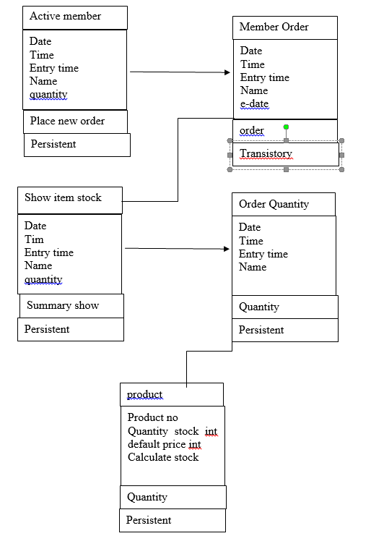

## SEQUENCE DIAGRAM

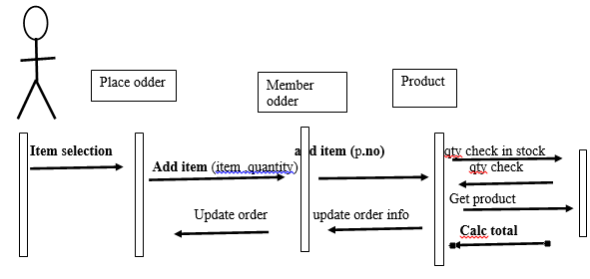

## INPUT PROTOTYPE

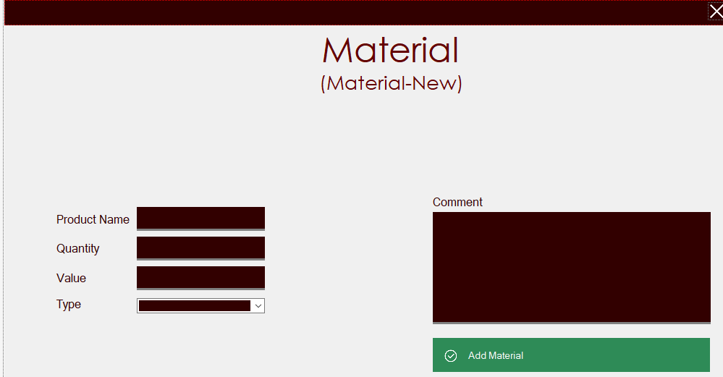

## 

## OUTPUT PROTOTYPE

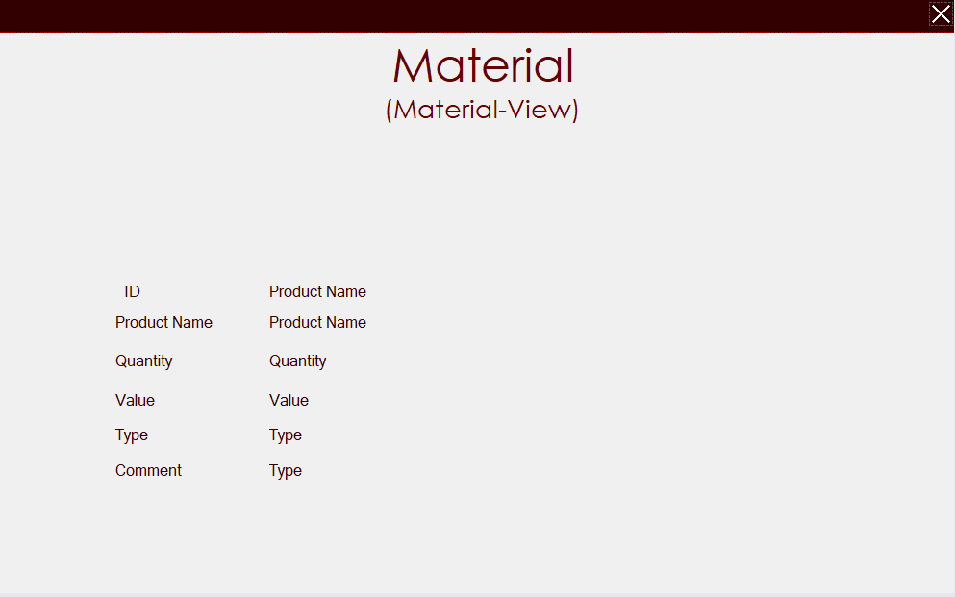

|  |  |  |  |
| --- | --- | --- | --- |
| **Use-Case Name:** | **Display stock summary.** | | **Use Case Type**  **Business Requirements:** |
| **Use Case ID:** | **CMS-ISUC 0004.00** | |
| **Priority:** | **High** | |
| **Source:** | **Requirement –CMS-ISUC 0003.00-CMS-ISUC 0002.00** | |
| **Primary Business Actor:** | **Supplier** | | |
| **Other Participating Actor:** | **Supervisor** | | |
| **Other Interested Stakeholders:** | **Stakeholder: interested in and responsible for checking stock summary for correct order placement.** | | |
| **Description:** | **This use case describes the brief summary of the stock which is to be places as order. And if it is verified and confirmed new order will be placed.** | | |
| **Precondition:** | * **New order must be placed.** * **Required order must be available in the stock.** | | |
| **Trigger:** | **This use case is initiated when a new order is placed and the stock is available in inventory.** | | |
| **Typical Course of Events:** | **Actor Action** | **System Response** | |
| **STEP NO.1: the supervisor requests to place a new order.**  **STEP NO.3: the supervisor goes through the list and selects the desired items along with its required quantity.**  **STEP NO.5: the supervisor reviews the stock summary and confirms the order.** | **STEP NO.2: system responds by displaying a cat loge list items available in inventory.**  **STEP NO.4: system stores the choices and generates a stock summary which is to be confirmed by the user.**  **STEP : on receiving confirmation , system generates an invoice billing receipt.** | |

|  |  |
| --- | --- |
| **Alternate Course:** | **STEP NO.2: system must display the available items along with their respective available quantity.**  **STTEP NO.3: if the supervisor doesn’t find the desired item in the list , he/she can switch to other suppliers.**  **STEP NO.5: if while placing order something got missing or a new thing needs to be added , it can be done before confirming order summary.** |
| **Conclusion:** | **This use case concludes when supervisor confirms the summary of the stock.** |
| **Post condition:** | **The order is confirmed by the supervisor, after its availability is checked. invoice and the order is generated and order is delivered.** |
| **Business Rules:** | * **Supervisor must be shown stock summary before finalizing order.** * **Supervisor can made amendments to it.** * **Stock summary must be generated before an order is finalized.** |
| **Implementation Constraints and Specification:** | **Use case must be editable.** |
| **Assumption:** | **Supervisor can edit or correct order summary.** |
| **Open Issues:** | **None.** |

## PARTIAL OBJECT DIAGRAM

**Supervisor**

NUMBER

DATE TIIME

STATUS

T-DATE

E-DATE

**Line Item**

NUMBER

NAME

DESCRIPTION

PRICE

**Employee**

NUMBER

NAME

DESCRIPTION

PRICE

PICTURE

# DESIGN USED CASED

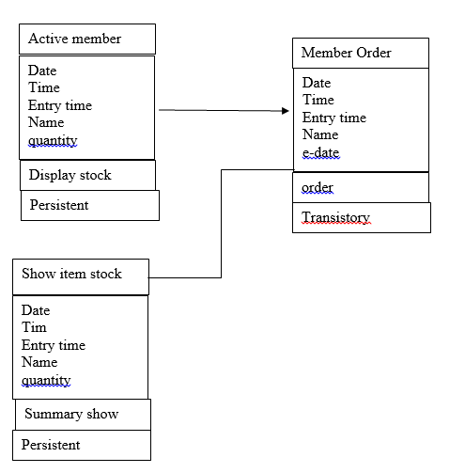

## SEQUENCE DIAGRAM

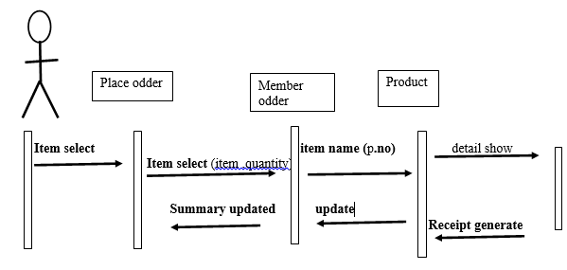

## INPUT PROTOTYPE

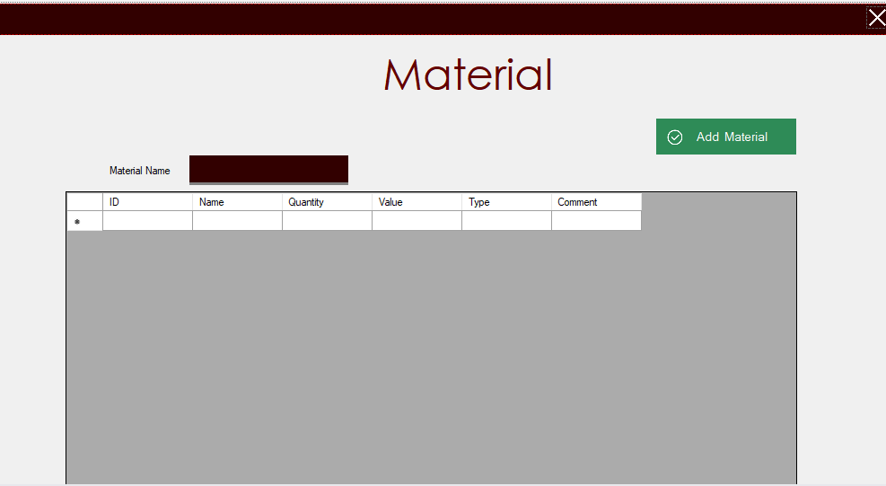

## OUTPUT PROTOTYPE

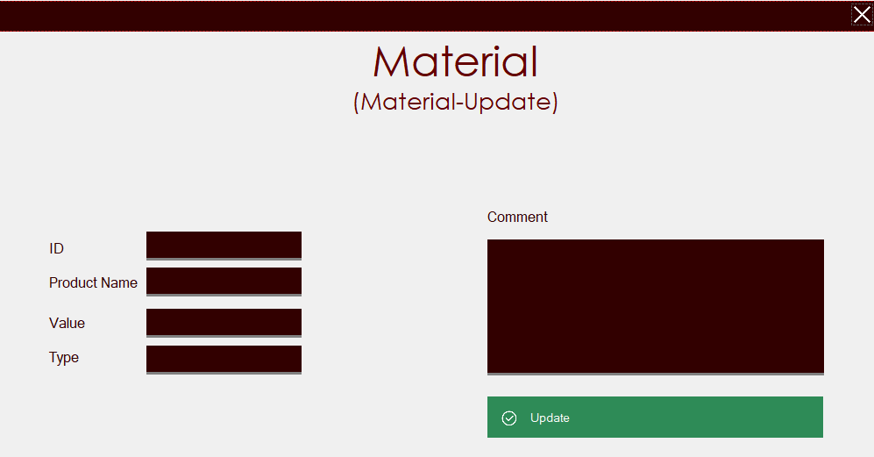

|  |  |  |  |
| --- | --- | --- | --- |
| **Use-Case Name:** | **Enter new Material.** | | **Use Case Type**  **Business Requirements:** |
| **Use Case ID:** | **IS-006** | |
| **Priority:** | **High** | |
| **Source:** | **suppliers** | |
| **Primary Business Actor:** | **Supervisor.** | | |
| **Other Participating Actor:** | **Suppliers: warehouse**  **Account** | | |
| **Other Interested Stakeholders:** |  | | |
| **Description:** | **This use case define the entry of the new stock in inventory which was delivered by various suppliers.** | | |
| **Precondition:** | **The stock should not be available, user must be logged in.** | | |
| **Trigger:** | **This use case is initiated when user selects ‘enter new stock’.** | | |
| **Typical Course of Events:** | **ActorActin** | **System Response** | |
| **STEP NO.1: the user request to enter new stock.**  **STEP NO.3: the user entered the required stock information and press done.** | **STEP NO.2: the system responds by showing the panel and asking for the details of the stock.**  **STEP NO.4: system checks the required information then show the stock added successfully dialog box.** | |

|  |  |
| --- | --- |
| **Alternate Course:** | **STEP NO.4: the data type doesn’t match when entering the data.** |
| **Conclusion:** | **Stock added successfully.** |
| **Post condition:** | **The order is recorded and inventory database has been updated.** |
| **Business Rules:** | **The user have to enter the correct information about stock and payment.** |
| **Implementation Constraints and Specification:** | **Frequency: it is estimated that this use case will be executed when new stock arrive.** |
| **Assumption:** | **Suppliers have delivered the stock.** |
| **Open Issues:** | **None.** |

## PARTIAL OBJECT DIAGRAM

**Supervisor**

USER ID

PASSWORD

NAME

ABOUT

ROLE

**Item**

ITEM ID

NAME

DESCRIPTION

UNIT PRICE

INT STOCK

TOTAL PRICE

QUANTATY USED

TOTAL QUANTATY

**Inventory**

NAME

QUANTATY

CATEGORY

PRICE

TASK

LABOUR

LABOUR COUNT

MATERIAL COUNT

**Inventory**

DATA

PARTICULARS’CEDIT

DEBIT

BALANCE

**Account**

## SEQUENCE DIAGRAM

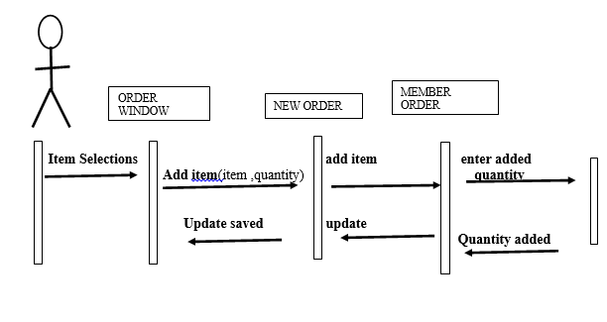

## INPUT PROTOTYPE

